ANIMATRONICS FACE: PROFESSOR ENDER FINOL

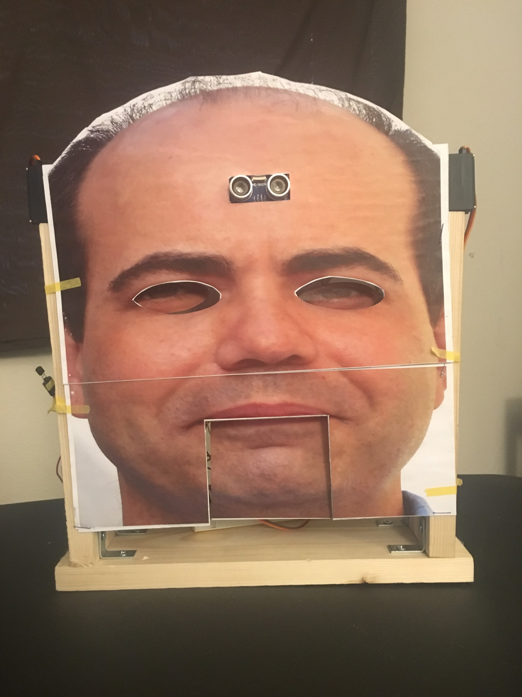

Jose Ruiz

Dept. of Mechanical Engineering

San Antonio, TX, USA 78249

arminruiz17@gmail.com

William Carroll

Dept. of Mechanical Engineering

San Antonio, TX, USA 78249

williamc475@gmail.com

Ty Morrison

Dept. of Mechanical Engineering

San Antonio, TX, USA 78249

ewb873@my.utsa.edu

Submitted as part of project for ME4543 Mechatronics, Fall 2018

TABLE OF CONTENTS

|  |  |
| --- | --- |
| Topic | Page number |
| Abstract | 2 |
| Literature Review | 3-5 |
| Supporting Structure | 5 |
| Joints and Motors | 6 |
| Sensors | 6-7 |
| Programming | 7 |
| Lesson learnt and suggestions | 7-8 |
| Personnel and Bill of Materials | 8-9 |
| Appendix A: Code snippets | 11-14 |
| Appendix B: Final Pictures | 15-16 |

**ABSTRACT**

In this project the team was tasked with creating an animatronic face of a professor with at least 2 moving joints. The team accomplished this using an ultrasonic sensor and a TMP36 temperature sensor. The ultrasonic sensor triggered eye movement followed by the mouth opening and closing, while the temperature sensor triggered horns to pop up and eyes to rotate to red eyes. 5 motors were used in total, one for each horn and eye, and one for the mouth. Once the face was assembled and all motors tested, the team programmed the motors to work properly based on the input of each sensor.

**Section 1: Literature review**

Kosmo’s face is made using basic Arduino servos, scrap wood, and other miscellaneous parts. The servos control the eyes, mouth, and eyebrows. Four servos are used to control the eyes. Two of the servos are used for left and right motion and the other two are used for up and down motion. The mouth only uses one servo. The upper jaw is fixed in place while the lower jaw is free to move. The servo is attached to the back of the lower jaw and moves back and forth to open and close the mouth. I’m not sure how the eye brows are manipulated because the creator did not explain it. The face is connected to a synthesizer and is manipulated by knobs and audio input. There are audio input connections next to the knobs that have different parameters that affect the face.

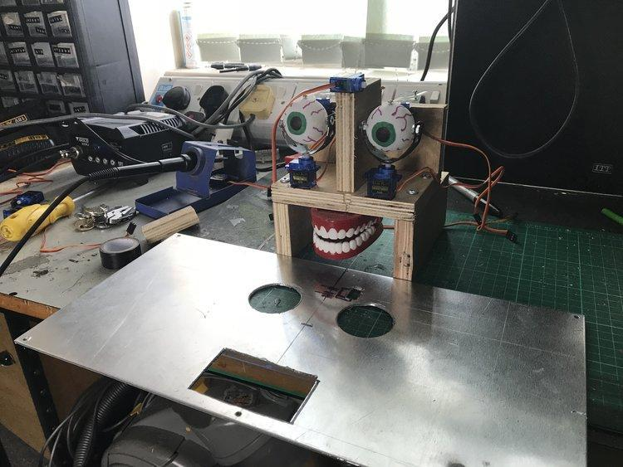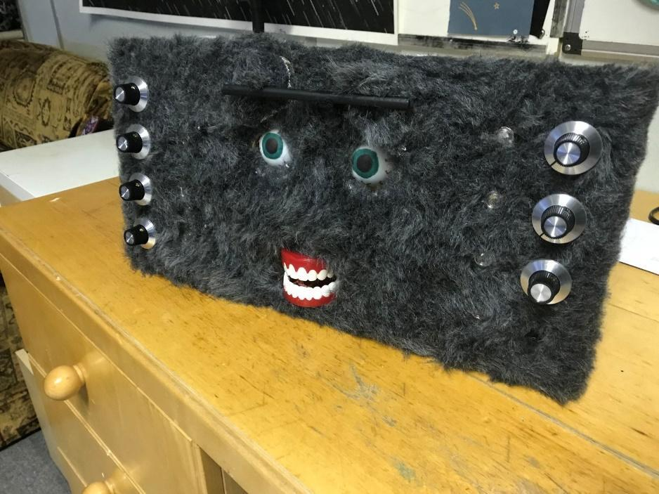

Figure 1. Kosmo Structure Figure 2. Complete Kosmo

The Jurassic Park series has always used animatronics to control and make the creatures look more realistic. The T-rex is an iconic part of the franchise and was made life sized using motors and animatronics. Each moving part had a set of motors used to control specific movements including rotation of the eyes, left and right, up and down, movement of the jaw up and down, and even moving the tongue inside the jaw. First they built a metal skeleton with joints, and then wired in and mounted the motors to move and control the head with control arms and programming. There were no sensors used, just motors and wiring to control the head and body. These were used in every Jurassic Park movie and made the dinosaurs seem more realistic since there was actually something there.

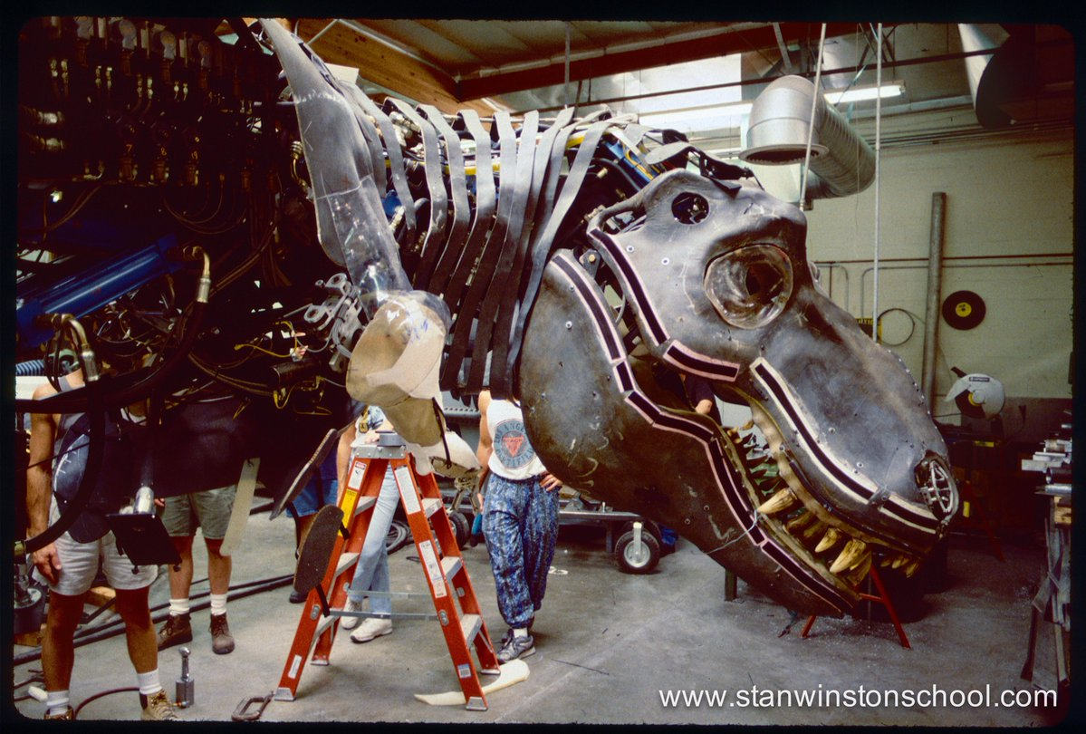

Figure 3. Animatronic T-rex

Disney’s animatronic Abraham Lincoln has been improved by a company called Garner Holt Productions. The animatronic face is a molded mask that has hair inserted into it and is painted over several times to help simulate real life human skin. It has a base metal frame that is controlled by over more than 40 different actuators that create an infinite number of facial expressions. Together, all those different actuators help with control of Lincoln’s eyes, lips, nose, eyebrows and other parts linked to the face. The neck of the animatronic also has seven human-like vertebrae that allow for smooth movement of the neck when speaking. The main purpose for this Abraham Lincoln creation is to primarily work as controlled animatronic that recites what it’s told to say and make expressions for Disney Park attendees. In the video, there was mention of improvements that would include the use of facial recognition and a type of AI system to create a more interactive experience with the park guests, but those were subject to come.

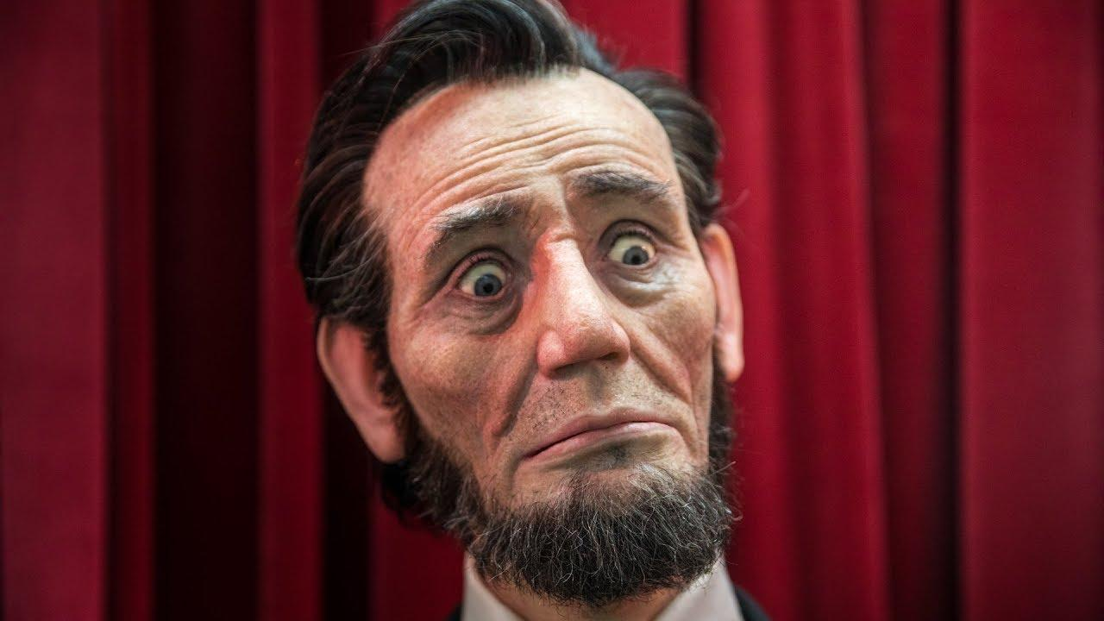

Figure 4. Animatronic Abe Lincoln

**Section 2: Brainstorming (initial planning)**

For our animatronic face of Dr. Finol, we’d like to be able to move his eyes vertically, as well as his eyebrows in the same way, and move his lower lip/jaw so it moves in sync with the recording. The eyes would probably be controlled by servo motors and fishing string. The eyebrows will be either a combination of servo motors and tiny pulley arrangements or using a type of slider. Lastly, the lower jaw would be controlled the same as the eyebrow arrangement or with a lever and motor combination. In terms of the stimulus, it would probably be an ultrasonic sensor that detects when a person waves their hand in front of the face. The structure will be made out of wood and the paper face will probably be overlaid as a cut out printed copy with holes in it for movement of chosen joints. Powering the Arduino, motors and sensors will likely be a battery pack plugged into the Arduino, and the motors and sensors powered by the Arduino. If need be, more battery packs can be wired into the system to power the motors and sensors individually. The soundtrack should be recorded with simple words to allow synced jaw movement and made to play when the animatronic starts to speak. “Civil engineering is too easy.” “Hmmm.” “Your final is optional.” “Good morning class.” “Bernoulli’s equation is extremely versatile.”

**Section 3: Supporting structure**

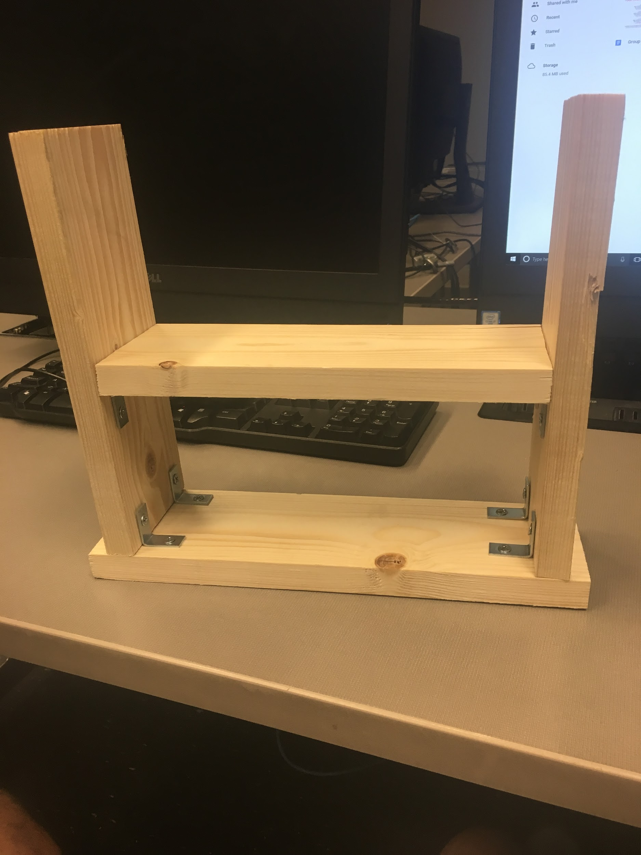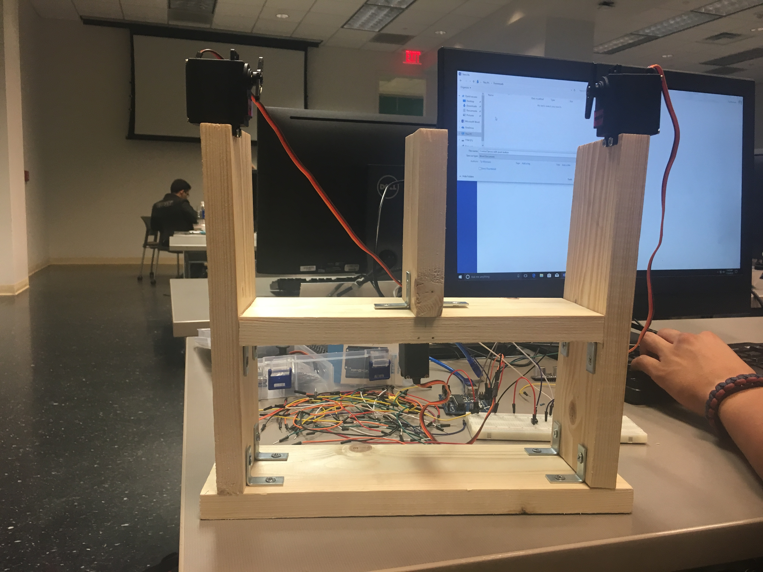

Figure 5. Base Frame Figure 6. Full Frame

We decided to use wood as the supportive structure to be sturdy enough for all the sensors and motors being used. As shown above, a middle section was added as a place for the face to be mounted, and act as the top part of the mouth. A small piece of wood was added onto this middle section vertically to add as the bridge between the eyes. The face was printed out and glued to a hard, flat piece of plastic to give it rigidity. The eyes were cut out to be allowed to move while attached to the motors, and the lower mouth and chin were also cut to provide movement of the mouth when attached to the servo motor. The structure was built slightly large, so the face also had to be scaled up to match the size of the structure and placement of the motors.

**Section 4: Joints and motors**

The team decided to use a minimum of 3 motors, one for the mouth to move up and down and 2 for the horns to move up and down. In addition, two more motors were added to allow the eyes to move left and right. The team chose Longrunner LKY62 high torque motors to ensure plenty of power were readily available to move any joint. Eyes were bolted through a piece of metal and then screwed on to the servo to allow left and right movement. The mouth was super glued onto the side of the frame, and a plastic tubing glued to the servo that allowed the mouth to have up and down movement. The horns were done with what were previously the eyebrow motors, and two cut out horns were glued to flat plastic for rigidity, then glued to the servos to allow easy up and down movement.

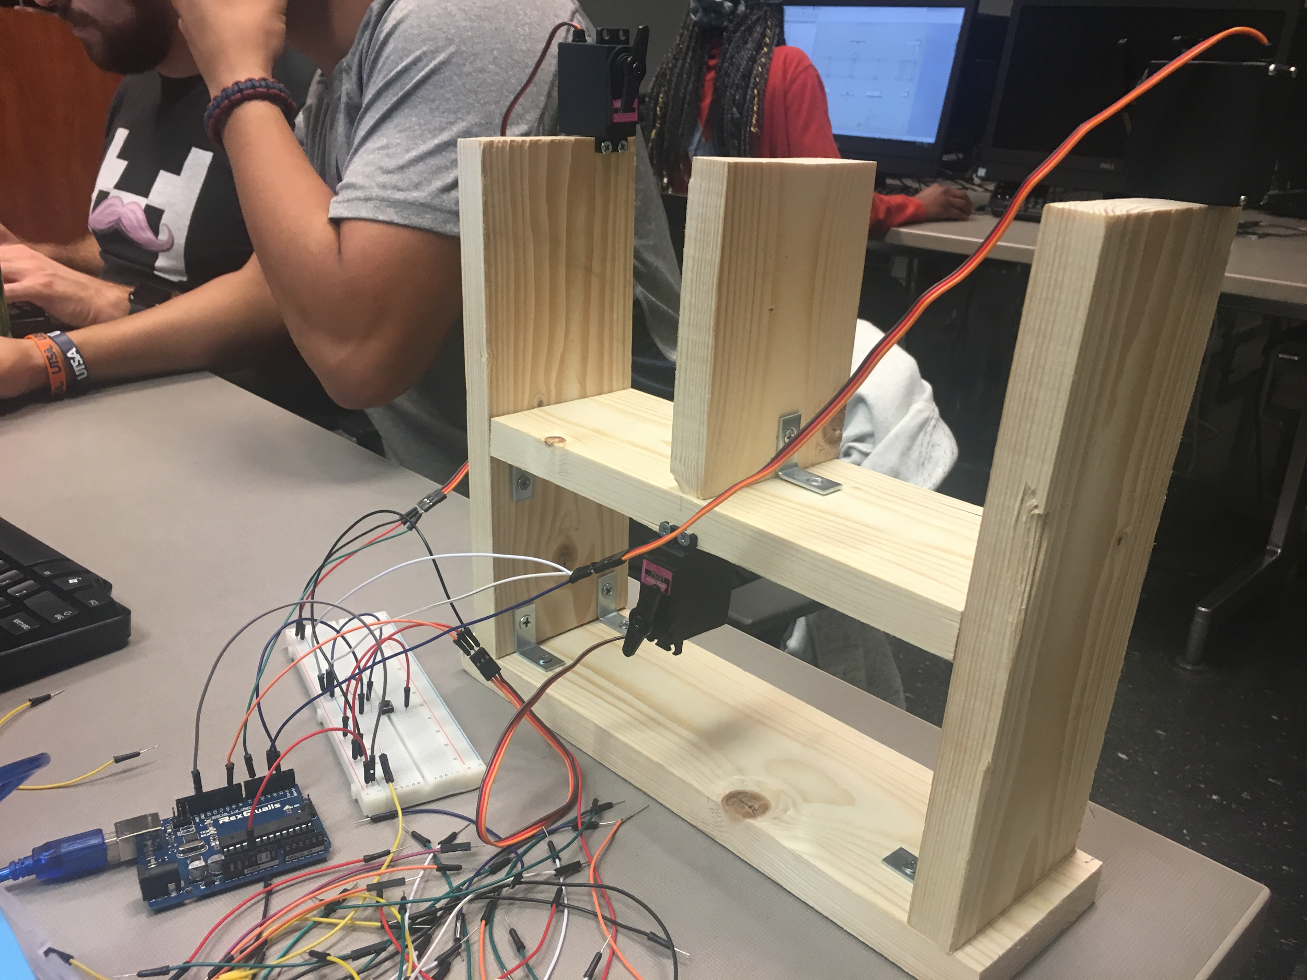

Figure 7. Initial Motor Setup Figure 8. Initial Wiring Setup

**Section 5: Sensors**

For sensors the team decided to use an ultrasonic sensor and a temperature TMP36. We chose these two as we felt these two would be the simplest to employ, use and demonstrate. An ultrasonic sensor consists of two parts, a transmitter and a receiver. The transmitter emits a sound wave at a frequency too high for humans to hear. The receiver waits for the sound wave to be reflected back so the sensor can calculate the distance based on the time required. The temperature sensor works by reading the voltage across the diode and converting it to temperature. If the voltage increases the temperature increases and vise versa.

The ultrasonic sensor is used to activate the eyes and mouth. When a distance of 20mm or less is read by the sensor the eyes move left and right and the mouth moves up and down in sync with the recording of our profesor. The temperature sensor is used to trigger the eyes and horns of the face. When the temperature sensor is pinched and reads a temperature above 30 $∘C$ the eyes move right $90∘$ revealing red eyes and the horns flip up.

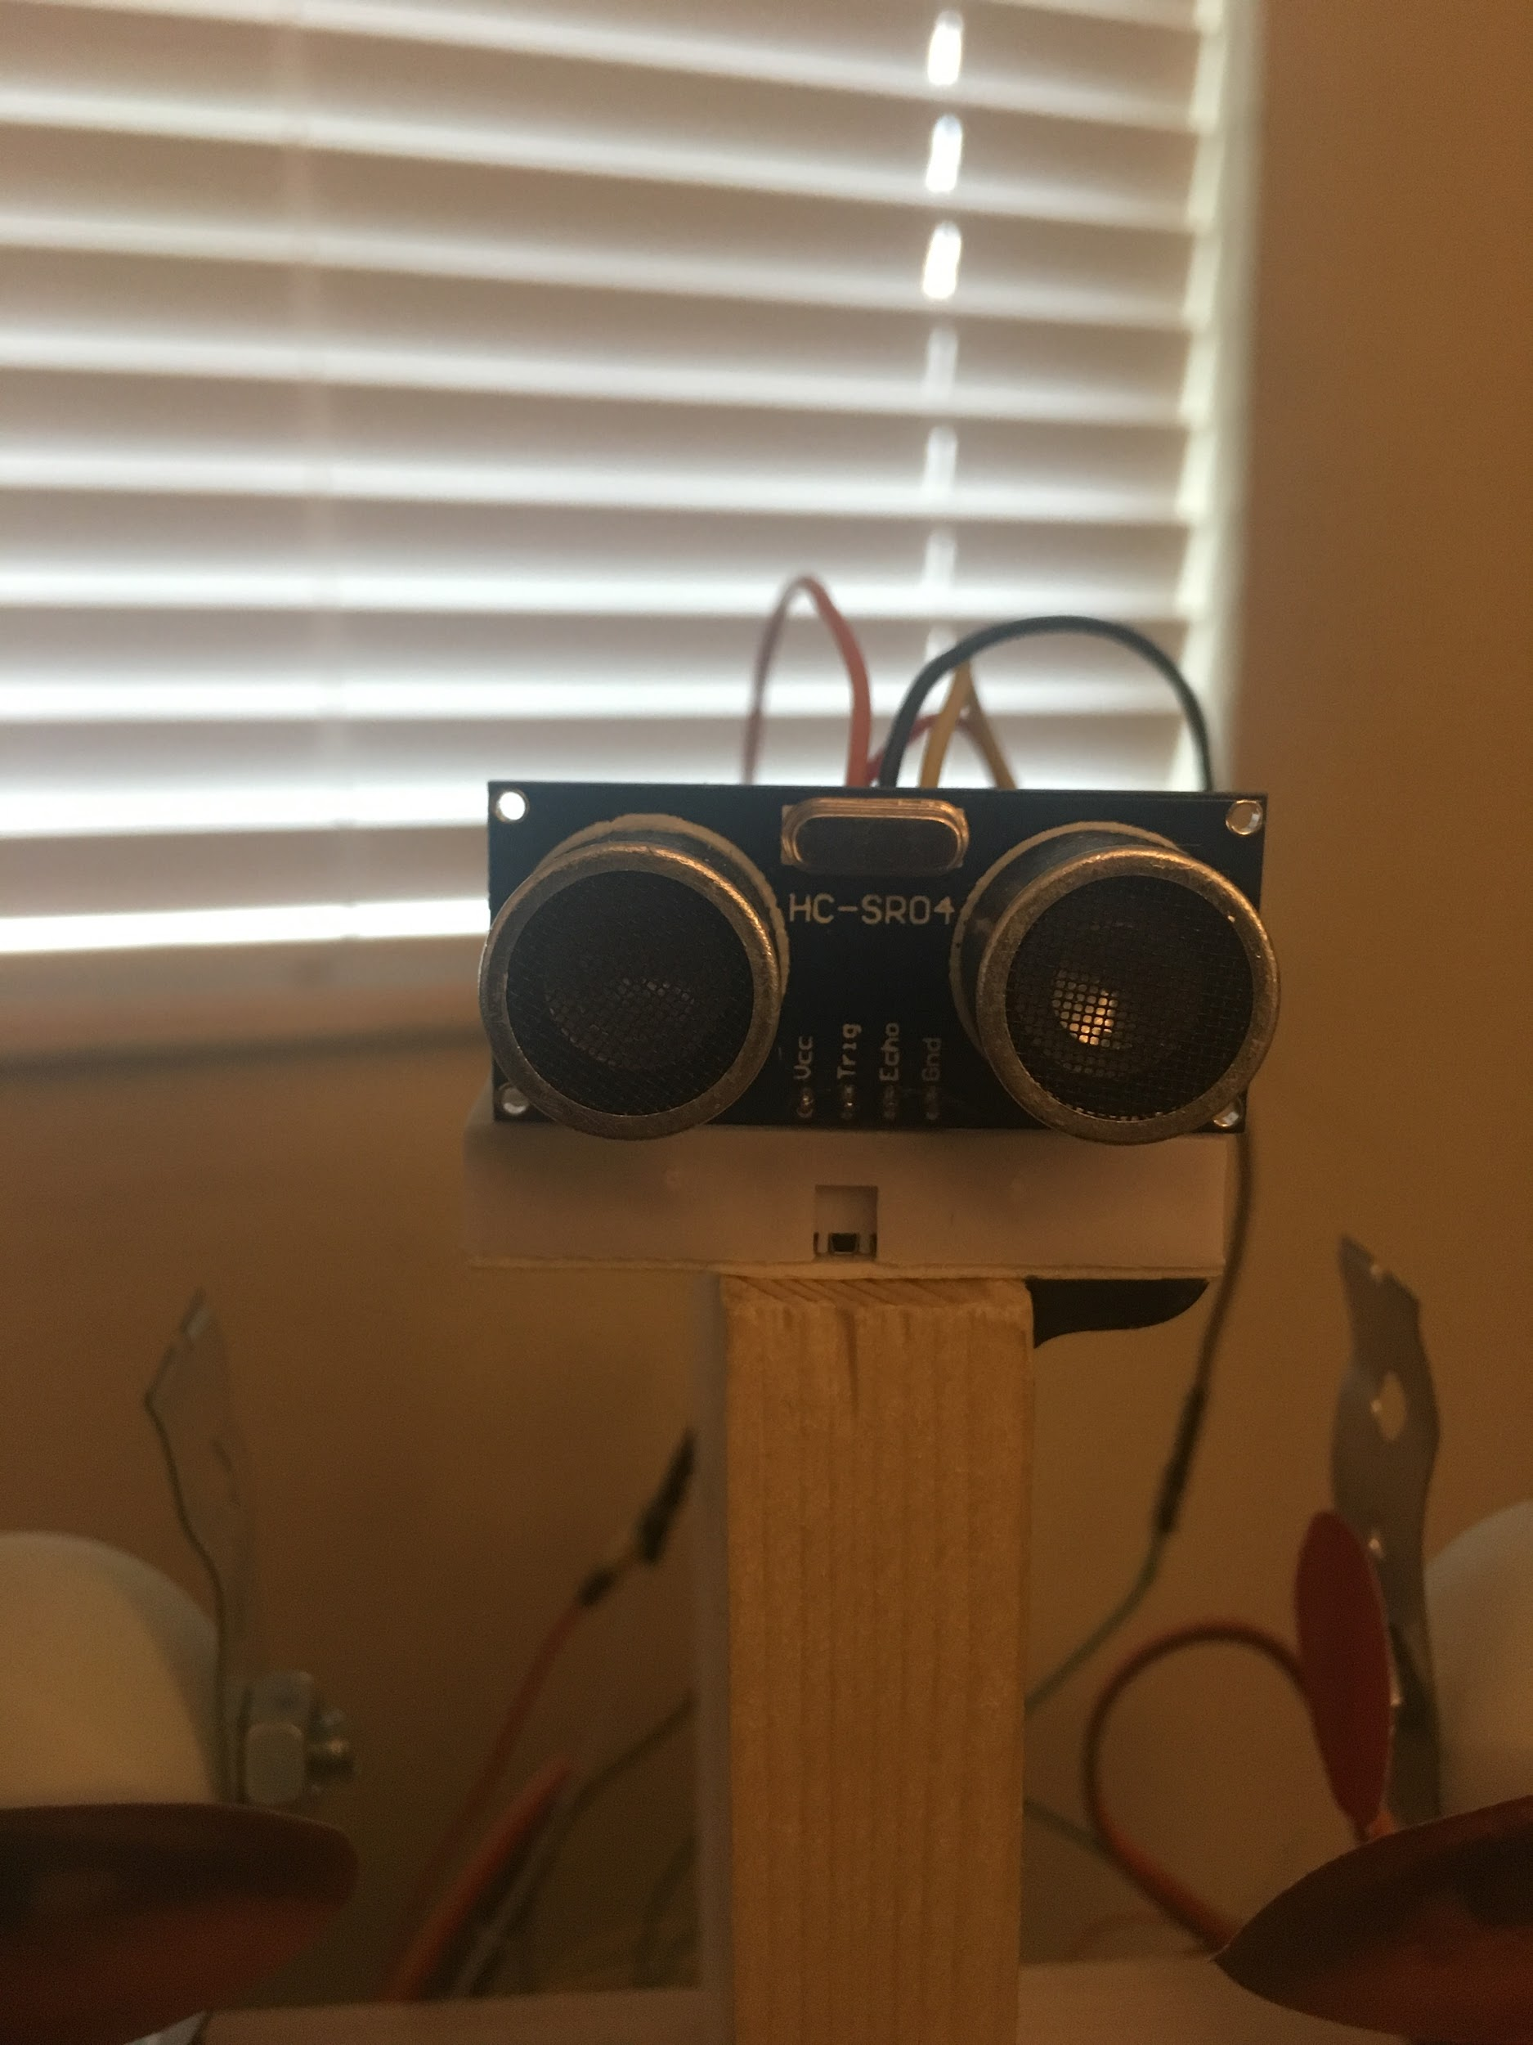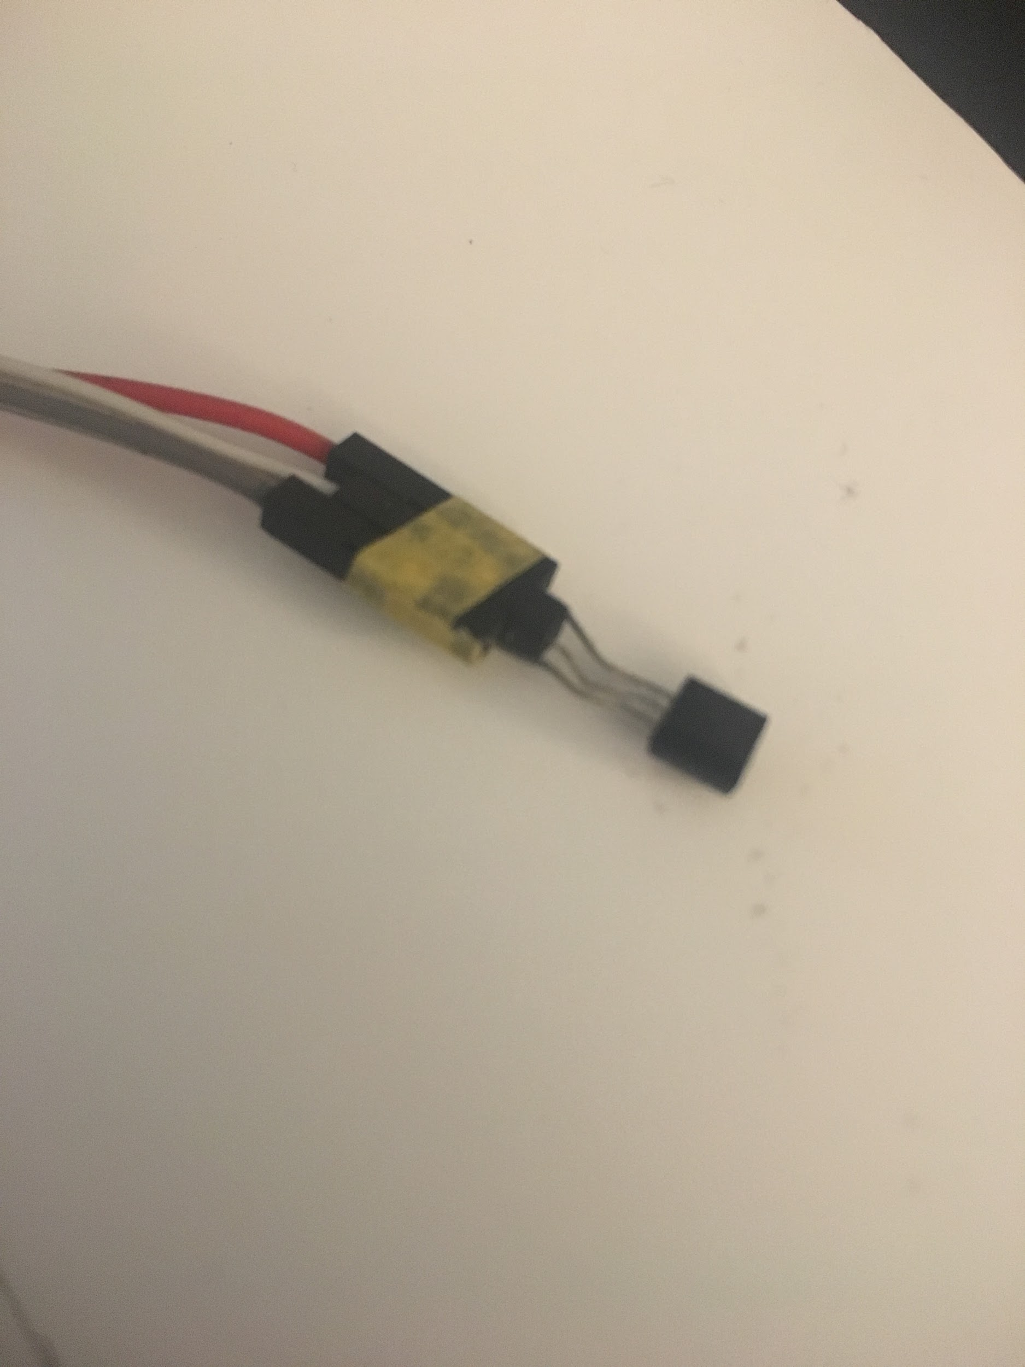

Figure 9. Ultrasonic Sensor Figure 10. TMP36 Sensor

**Section 6: Programming for interaction**

Essentially, we originally wanted to control the eyes and the mouth simultaneously as the ultrasonic sensor is triggered. We ran into problems because arduino was not able to supply enough power to all the motors that we wanted to control. We then decided to make the actions act in series to format the audio. The horns were controlled by the change in the voltage from the TMP36 sensor going into arduino.

In the first code with the ultrasonic sensor, we initialized the echo and trig pin to the proper input and output setup and then continued the basic commands to record the distance in centimeters. We then used the “if” statement to trigger the eyes and mouth servos only if the person was within a distance of 20 cm. The eye servos operated first by calling the position of the servos per movement with the proper delay in between. The mouth operated in the similar manner by setting the position with delays to best play alongside the audio. The action we were going for was him looking around to find you and then talking once he located you (position of 90 degree).

For the second code, we wanted to simulate Dr. Finol getting mad after you pinched his ear. We started by creating the pin of the TMP36 as an input pin and creating another “if” statement. The “if” statement pretty much said that if the voltage reading from the TMP36 jumped above 185 mV, the servomotors (horns) would prop up and the eyes would turn to show his red eyes. An “else” statement was added to return the servos to their original position once the voltage had dropped below 185 mV.

Here is a video of the final product.

https://www.youtube.com/watch?v=nNwBHxSKxCY

**Section 7: Lessons learnt and suggestions (1 page)**

Lessons Learned

1. Gather materials as early as possible
   1. Three times we realized we needed more materials and had to either order or scramble to Home Depot to buy materials to continue/finish the project
2. Always have a backup plan in case something fails
   1. Two things happened to make this a lesson learned, first the initial secondary sensor bring the button would not work whatsoever with any code we used, so it had to be switched. Second, the provided Arduino Mega died and wouldn’t work with any uploaded code so a backup Arduino had to be used.
3. Alot time to debugging and ensuring code works (it won’t)
   1. Many, many times our code had problems either controlling motors properly, activating sensors correctly, or plain problems that wouldn’t upload, so time was needed to debug and make sure the code would work.
4. Things aren’t as simple as they may appear
   1. Multiple times the team would leave early or presume something an easy task, and be blindsided by much larger potential problems. Meeting more and taking everything at face value would’ve saved a lot of trouble, which is what the team began to do towards the end.

Suggestions

1. Use external resources
   1. External resources such as professors, other students or online tutorials can easily help understand or figure out troublesome code or wiring systems
2. Spread out work days or meet more often
   1. The team was able to meet and finish the project but at times that we were tired or unproductive. In addition, so much time would be spent in one sitting that the Arduinos started to struggle and fail in some cases. Spreading out these times and meeting earlier in the day would solve both issues.

**Section 8: Personnel and bill of materials**

**(a) Personnel**

|  |  |  |
| --- | --- | --- |
| Task | Main Personnel | Secondary personnel |
| Structure/Chassis Design | William Carroll | Jose Ruiz |
| Creating Joints and Motor interfacing | William Carroll | Ty Morrison |
| Integrating Sensors | Ty Morrison | Jose Ruiz |
| Overall Programming and Integration | Jose Ruiz | Ty Morrison |

**(b) Bill of materials**

|  |  |  |  |  |  |
| --- | --- | --- | --- | --- | --- |
| No. | Description | Website/comment | Qty. | Unit $ | Total $ |
| 1 | Arduino MEGA 2560 | Provided | 1 | 0 | 0 |
| 2 | High Torque Servos | Pack of 10 - <https://www.amazon.com/gp/product/B01MTW06IU/ref=oh_aui_detailpage_o00_s00?ie=UTF8&psc=1> | 1 | 46.99 | 46.99 |
| 3 | Wood | Home Depot | 1 | 6 | 6 |
| 4 | Ping Pong Balls | Pack of 50 - <https://www.amazon.com/gp/product/B018JZSEVY/ref=oh_aui_detailpage_o05_s00?ie=UTF8&psc=1> | 1 Pack | 9.99 | 9.99 |
| 5 | Metal Sheet for Plumbing | Home Depot | 1 Roll | 7 | 7 |
| 6 | Screws | Home Depot | 1 Pack | 7 | 7 |
| 7 | Bolts and Nuts | Home Depot, 1 nut and 1 bolt per | 2 | 2 | 4 |
| 8 | Super Glue | 2 Pack - <https://www.amazon.com/gp/product/B00JN1E4TK/ref=oh_aui_detailpage_o06_s00?ie=UTF8&psc=1> | 1 | 8.52 | 8.52 |
| 9 | Plastic Tubing | Scrap | 1 | 0 | 0 |
| 10 | TMP36 Sensor | From owned kit | 1 | 0 | 0 |
| 11 | Ultrasonic Sensor | From owned kit | 1 | 0 | 0 |
| 12 | Zip Ties | Pack of 100 - <https://www.amazon.com/gp/product/B01018DC96/ref=oh_aui_detailpage_o05_s00?ie=UTF8&psc=1> | 1 | 5.99 | 5.99 |
|  | **TOTAL** |  |  |  | 95.49 |

The total price for this project excluding the Arduino MEGA was **$95.49**.

**Acknowledgements**

Thanks to our TA Sal for being a great TA and professor Bhounsule for pushing to do more.

We wish to thank Dr. Finol for letting us use his likeness and voice, as well as Salvador for his advice and help on the project.

**References**

# [1] KOSMOS FACE – ANIMATRONIC FACE ROBOT <https://www.lookmumnocomputer.com/projects/#/kosmos-face/>

# [2] JURRASIC PARK T-REX – ANIMATRONIC FACE ROBOT <https://www.youtube.com/watch?v=4SK1qTnhHzI>

# [3] DISNEY ABRAHAM LINCOLN FACE – ANIMATRONIC FACE ROBOT

# <https://www.youtube.com/watch?v=F1PI1FOYJoM>

**Appendix A: Code**

**#include <Servo.h>**

**Servo righteye; // create servo object to control a servo**

**Servo lefteye;**

**Servo rightbrow;**

**Servo leftbrow;**

**Servo mouth;**

**const int trigPin = 9;**

**const int echoPin = 10;**

**const int buttonPin = 2;**

**int buttonState=0;**

**int directionState=0;**

**int pos=0;**

**float temp;**

**int tempPin = A0;**

**int tempMin = 186;**

**void setup() {**

**// initialize serial communication:**

**righteye.attach(3);// attaches the servo on pin 9 to the servo object**

**lefteye.attach(11);**

**mouth.attach(8);**

**//tempsensor**

**rightbrow.attach(6);**

**leftbrow.attach(12);**

**//mouth.write(directionState);**

**pinMode(tempPin, INPUT);**

**Serial.begin(9600);**

**}**

**void loop() {**

**// and the distance result in centimeters:**

**long duration, cm;**

**pinMode(trigPin, OUTPUT);**

**digitalWrite(trigPin, LOW);**

**delayMicroseconds(2);**

**digitalWrite(trigPin, HIGH);**

**delayMicroseconds(20);**

**digitalWrite(trigPin, LOW);**

**pinMode(echoPin, INPUT);**

**//buttonState = digitalRead(buttonPin);**

**duration = pulseIn(echoPin, HIGH);**

**// convert the time into a distance**

**cm = microsecondsToCentimeters(duration);**

**// the condition for the distanse**

**if (cm < 20)**

**{**

**righteye.write(115); //eyes go left**

**lefteye.write(115);**

**delay(250);**

**righteye.write(135); // eyes go back to rest position**

**lefteye.write(135);**

**delay(250);**

**righteye.write(115);**

**lefteye.write(115);**

**delay(250);**

**righteye.write(90);**

**lefteye.write(90);**

**delay(250);**

**righteye.write(70);**

**lefteye.write(70);**

**delay(250);**

**righteye.write(45);**

**lefteye.write(45);**

**delay(250);**

**righteye.write(70);**

**lefteye.write(70);**

**delay(250);**

**righteye.write(90);**

**lefteye.write(90);**

**delay(250);**

**mouth.write(80);**

**delay(200);**

**mouth.write(100);**

**delay(500);**

**mouth.write(80);**

**delay(200);**

**mouth.write(100);**

**delay(200);**

**mouth.write(80);**

**delay(200);**

**mouth.write(100);**

**delay(200);**

**mouth.write(80);**

**delay(200);**

**mouth.write(100);**

**delay(200);**

**mouth.write(80);**

**delay(200);**

**mouth.write(100);**

**delay(1000);**

**mouth.write(80);**

**delay(200);**

**mouth.write(100);**

**delay(200);**

**mouth.write(80);**

**delay(200);**

**mouth.write(100);**

**delay(200);**

**mouth.write(80);**

**delay(200);**

**mouth.write(100);**

**delay(200);**

**mouth.write(80);**

**delay(200);**

**mouth.write(100);**

**delay(200);**

**mouth.write(80);**

**delay(200);**

**mouth.write(100);**

**delay(200);**

**mouth.write(80);**

**delay(200);**

**mouth.write(100);**

**delay(200);**

**mouth.write(80);**

**delay(200);**

**mouth.write(100);**

**delay(200);**

**mouth.write(80);**

**delay(200);**

**mouth.write(100);**

**delay(200);**

**}**

**else**

**{**

**righteye.write(90);**

**lefteye.write(90);**

**//rightbrow.write(45);**

**//leftbrow.write(115);**

**mouth.write(100);**

**delay(750);**

**}**

**Serial.print(cm);**

**Serial.print("cm");**

**Serial.println();**

**delay(200);**

**//Temperature Sensor Load**

**temp = analogRead(tempPin);**

**temp = (temp * (5000/1024)-500/10);**

**Serial.println(temp);**

**delay(5);**

**if(temp > tempMin)**

**{**

**leftbrow.write(90);**

**rightbrow.write(90);**

**delay(500);**

**righteye.write(180);**

**lefteye.write(180);**

**//mouth.write(60);**

**delay(500);**

**righteye.write(270);**

**lefteye.write(270);**

**//mouth.write(60);**

**delay(500);**

**} else {**

**righteye.write(90);**

**lefteye.write(90);**

**delay(500);**

**rightbrow.write(0);**

**leftbrow.write(180);**

**//mouth.write(100);**

**delay(500);**

**}**

**}**

**long microsecondsToCentimeters(long microseconds) {**

**// The speed of sound is 340 m/s or 29 microseconds per centimeter.**

**// The ping travels out and back, so to find the distance of the**

**// object we take half of the distance travelled.**

**return microseconds / 29 / 2;**

**}**

**Appendix B: Final Pictures**

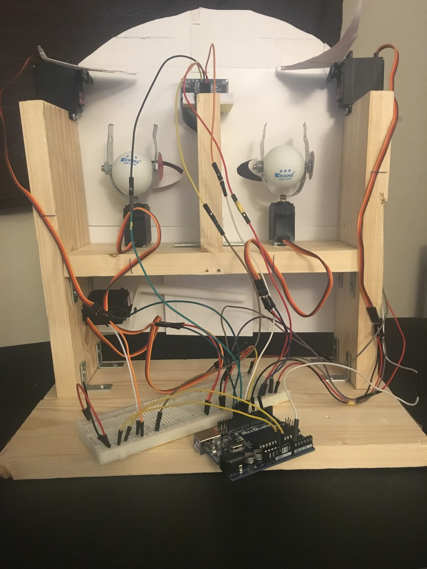

Figure 11. Final Setup

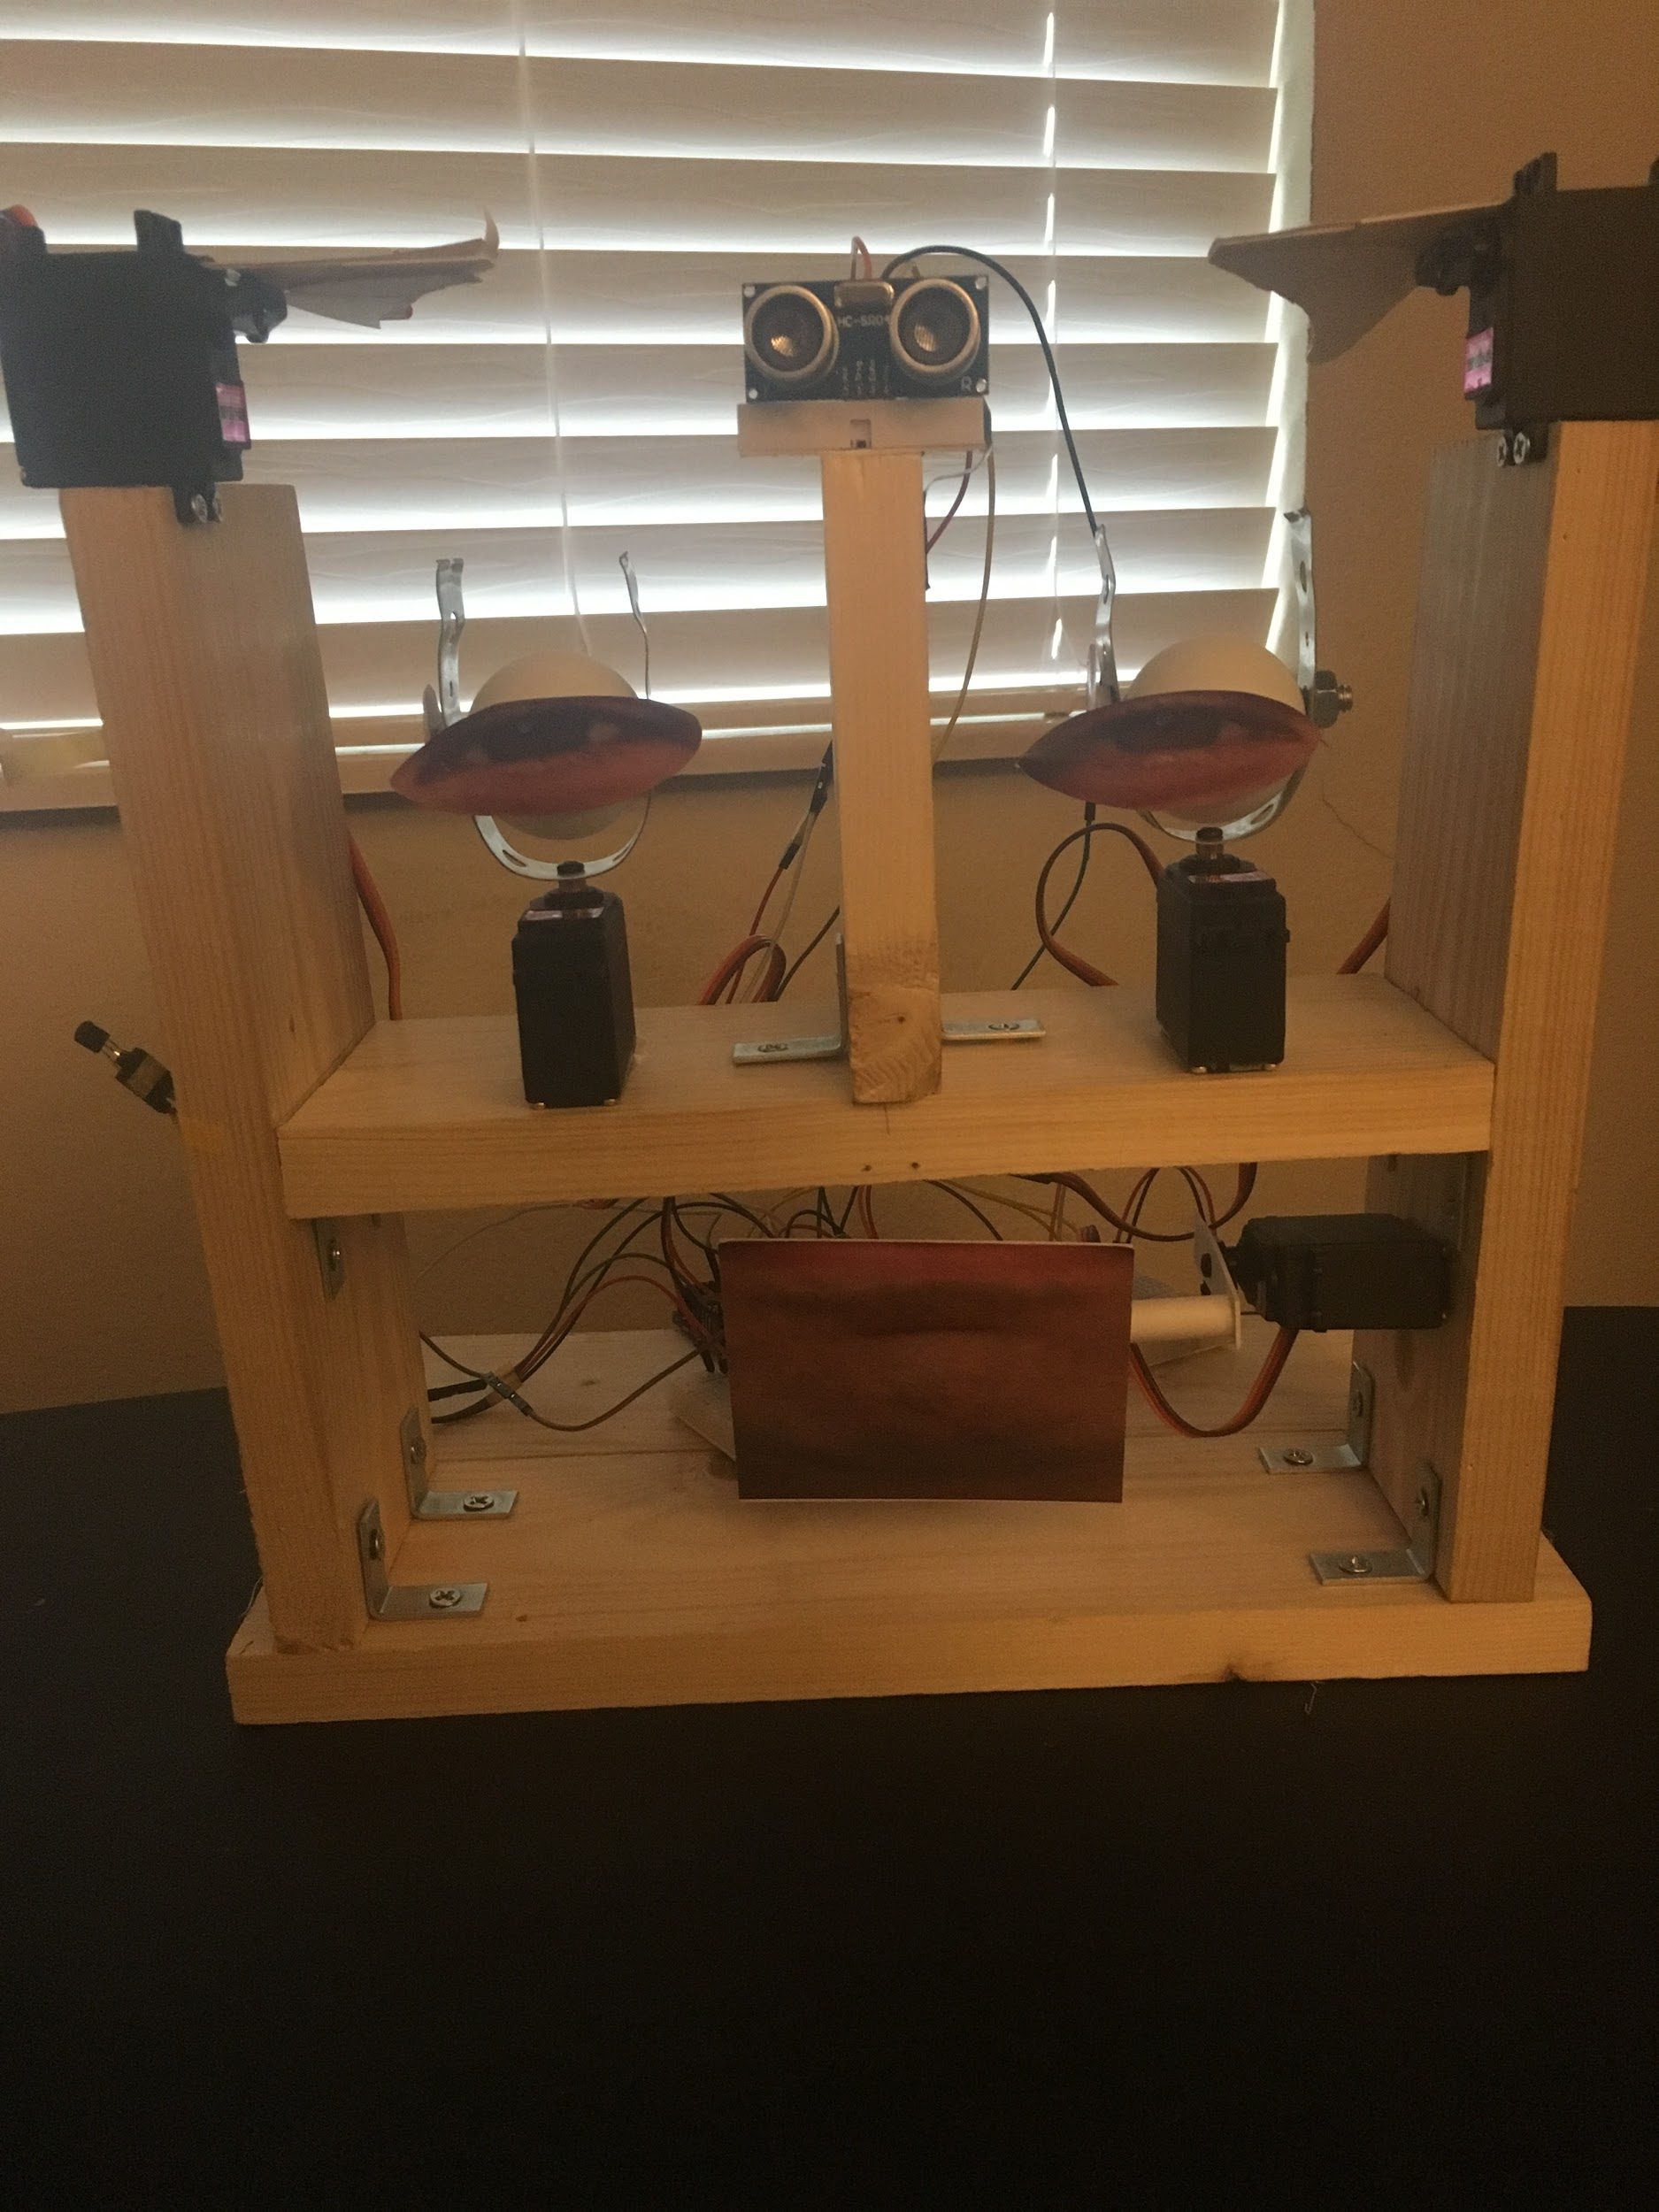

Figure 12: Final Setup Front View